# Balancing Life: Work, Leisure, and Living

# Timothy Robinson

# Old Dominion University

# Balancing Life: Work, Leisure, and Living

Establishing a Work-Life Balance (WLB) is important in both maintaining a positive mental health in day-to-day life and sustaining healthy relationships with family, friends, and colleagues. According to Greenhaus and Powell (2006), the necessity for WLB stems from a hypothesis that because there is a fixed amount of time and human energy, those that maintain multiple roles (i.e., employee, parent, family) are inevitably going to experience conflict and stress that weaken their quality of life. This issue is supported through research on the work-family relationship which continues to emphasize conflict, stress, and impaired well-being. This has created an emphasize on positive interdependencies between work life and family life which is consistent with developments in psychology, behavior, and family studies that have shifted a focus on understanding individual potential and social systems. The development of a focus on the positive effects caused by a concise WLB has been slow going due to the lack of a comprehensive framework to compare results of research.

This paper examines the different factors that may affect people’s efforts to obtain an optimal balance between their work life, leisure life, and family life. Likewise, it will also elaborate on whether employers should develop a focus on supporting workers in their pursuit of WLB and if so, what practices they could implement to help.

Joanne Ciulla’s statement of “the way we think about work, leisure, and the way we live depends on how we see the big picture” means that peoples choices and lifestyles are dictated by what goals they currently have and what milestones they hope to achieve in the future. This can be the case in such situations such as a person’s financial status determining where/how they live to how they interact with the individuals in their daily life. Karakas and Lee (2004), as cited in Fatima & Sahibzada (2012), explain that work life balance issues that may arise include: spending good time with family members, getting free time to be able to relax for emotional wellbeing and health of family members, having good communication and support from the fellow colleagues, obtaining high quality childcare and education; and being satisfied with the workload. These can all be influenced by whatever the individual deems to be important at the time as well as whatever other factors may be impacting the way they choose to approach a situation.

To be able to ascertain an effective approach to the work-life balance subject, there must first be a thorough examination of what exactly are the factors that contribute to the way people work, leisure, and chose the way they live. In their research to categorize variables as work and family related factors and determine their effect on work-life balance, Fatima & Sahibzada (2012) created both a table that states some possible factors (See Figure 1) and a chart that displays their effects (See Figure 2). In their research, they had targeted their research towards university teachers and found that factors such as spousal supportiveness at home and colleague supportiveness at work were strong contributors to a positive work life balance whereas influences such as childcare problems, elder dependency at home and unfair work criticism were the main contributor to a negative work life balance. They also found that male workers were overall more satisfied with their work life balance then their female counterparts due to the fact that female workers felt a greater life strain from childcare responsibilities and the effects of elder dependency more; they establish this by citing Daly and Lewis (2000) who, in their own study, concluded that women still feel the societal belief that women are seen as the primary role of caretakers.

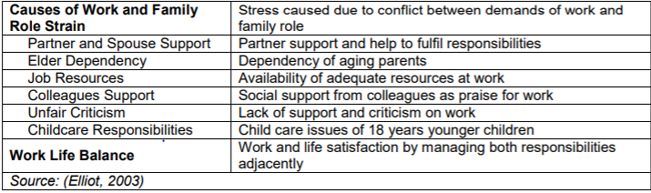

Figure 1: Factors influencing WLB

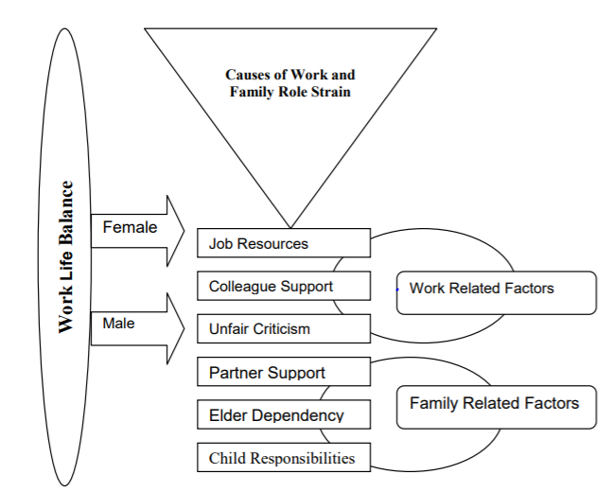

Figure 2: Process of causes and effects related to WLB

While it shouldn’t be their primary focus, I believe employers have an obligation if they truly care about their employees to provide some support to their struggle in balancing work, family, community life, and leisure. This would not only improve the employee’s wellbeing and mental health but also would result in benefits for the company as well. Greenhaus and Powell (2006) describe three ways that a balanced Work life and leisure life and produce positive outcomes: firstly, they state that work experiences and family experiences can have additive effects on well-being asserting that research has demonstrated that these experiences can have beneficial physical and psychological effects. Secondly, they contend that participation in both work and family roles can buffer individuals from distress in one of the roles and thus if the load of one is made easier then it may positively affect the other role. Lastly, the further elaborate that the experiences from one of the roles can produce positive experiences and outcomes. They state that as an individual accumulates a variety of roles (worker, caregiver, etc.) their personalities also become enhanced as they learn to be tolerant of conflicting views and become more flexible in meeting the demands for each diverse role.

Within the work-life balance argument, there are two differing sides that debate whether it is the responsibility of the organization or the individual. Shankar & Bhatnagar (2010) claim that a research in the WLB field have found that organizations that offer family friendly policies result in improved employee health and workplace environment; these policies include flexible work hours, paid holidays, on-site childcare centers, paid days of parental leave, adoption assistance, half-days of work on Fridays, and employee discounts. The ideal “balance life” is one in which an individual can remain to feel satisfaction for work they complete within their career while also not feeling like they are “drowning” in monotony or under a workload and are also able to maintain relationships and a steady living. This is supported in Olsen’s (2000) article which support that being able to balance between work and their parental responsibilities is not only displayed in a parents’ allotted time given to each role but rather their actual commitment during those times and a direct result of the effort put in which is reliant on their mindset and balance of importance between the two roles.

References

# Fatima, N., &amp; Sahibzada, S. (2012). An Empirical Analysis of Factors Affecting Work Life Balance among University Teachers: The case of Pakistan. Journal of International Academic Research, 12(1), 16-29.

# Greenhaus, J., & Powell, G. (2006). When Work and Family Are Allies: A Theory of Work-Family Enrichment. The Academy of Management Review, 31(1), 72-92. Retrieved April 5, 2021, from <http://www.jstor.org/stable/20159186>

# Olsen, D. (2000, July 01). Ask the Children: What America's children really think about Working Parents: DARCY ANN Olsen, ELLEN Galinsky. Retrieved April 05, 2021, from https://fee.org/articles/ask-the-children-what-americas-children-really-think-about-working-parents/

# Shankar, T., & Bhatnagar, J. (2010). Work Life Balance, Employee Engagement, Emotional Consonance/Dissonance & Turnover Intention. Indian Journal of Industrial Relations